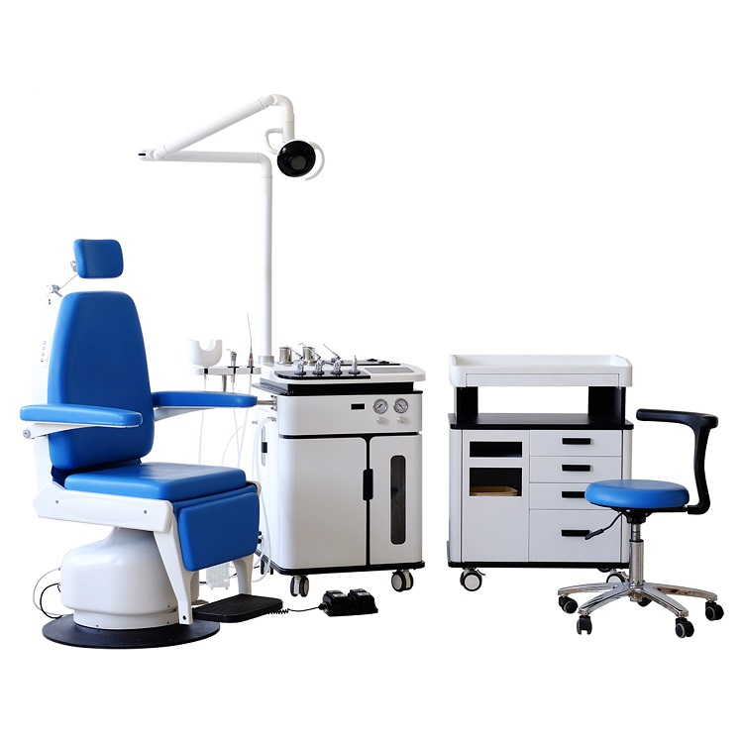

**ENT2800 set**

* **ENT2800A main operating unit 1**

Painted metal body and marble surface 1

Glass touch control panel 1

electronic control system 1

Medicine spray gun 3

Blowing gun 1

Suction gun 1

Compressor 1

Vacuum pump 1

Positive air pressure regulating 1

Negative air pressure regulating 1

Instrument jar 2

Ointment jar 1

Hot air heater 1

LED Inspection light 1

Sewage collection system 1

Auto drain off system 1

Built-in LED cold light 1

Constant temperature irrigation system 1

* **ENT2800C ENT cabinet 1**
* **ENT1900E electrical patient chair 1**
* **ENT1900A doctor stool 1**

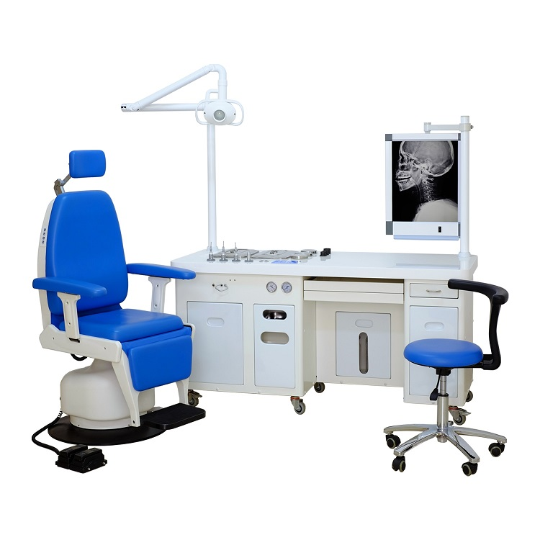

**ENT1800DC set**

* **ENT1800DC main operating unit 1**

Metal unit body 1

Electronic control system 1

Compressor 1

Vacuum pump 1

LED inspection light 1

Endoscope heater 1

Endoscope placement 3

Spray gun 3

Suction gun 1

Blowing gun 1

Instrument tray 2

Ointment jar 3

Sewage collect system 1

Built in trash bin 1

Built-in LED cold light 1

Used instrument tray 1

LED backlight X-ray view box 1

* **ENT1900E electrical patient chair 1**
* **ENT1900A doctor stool 1**

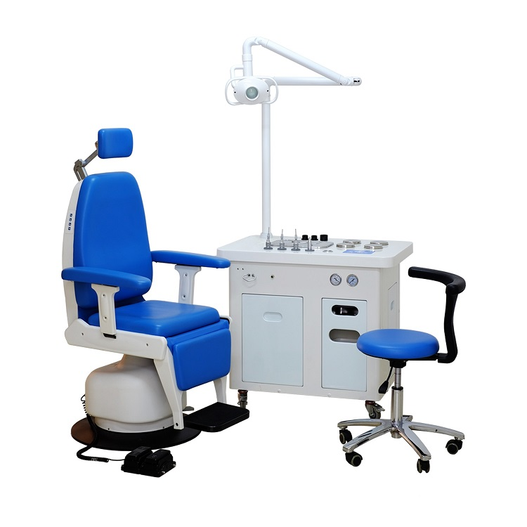

**ENT1800DP set**

* **ENT1800DP main operating unit 1**

Metal unit body 1

Electronic control system 1

Compressor 1

Vacuum pump 1

LED inspection light 1

Endoscope heater 1

Endoscope placement 3

Spray gun 3

Suction gun 1

Blowing gun 1

Instrument tray 1

Ointment jar 4

Sewage collect system 1

Built in trash bin 1

Built-in LED cold light 1

Used instrument tray 1

* **ENT1900E electrical patient chair 1**
* **ENT1900A doctor stool 1**